public void searchNode(String value) {  
 int i = 1;  
 Node current = head;  
  
 //Checks if list is empty  
 if (head == null) {  
 System.*out*.println("List is empty");  
 return;  
 }  
  
 int fnd = 0;  
 while (current != null) {  
 //Compare value to be searched with each node in the list  
  
 if ((current.data.equals(value)) == true) {  
 System.*out*.println("the same ");  
 System.*out*.println("Node is present in the list at the position : " + i);  
 break;  
 } else {  
  
 System.*out*.println("Node is not present in the list");  
 }  
  
 current = current.next;  
 i++;  
 }  
  
}

The searchNode() method used to search for a song by inputting its index position

The user enters the name of the song and the program returns the index position of the song and whether it is present in the list or not.

The song Dark, is not found in the playlist

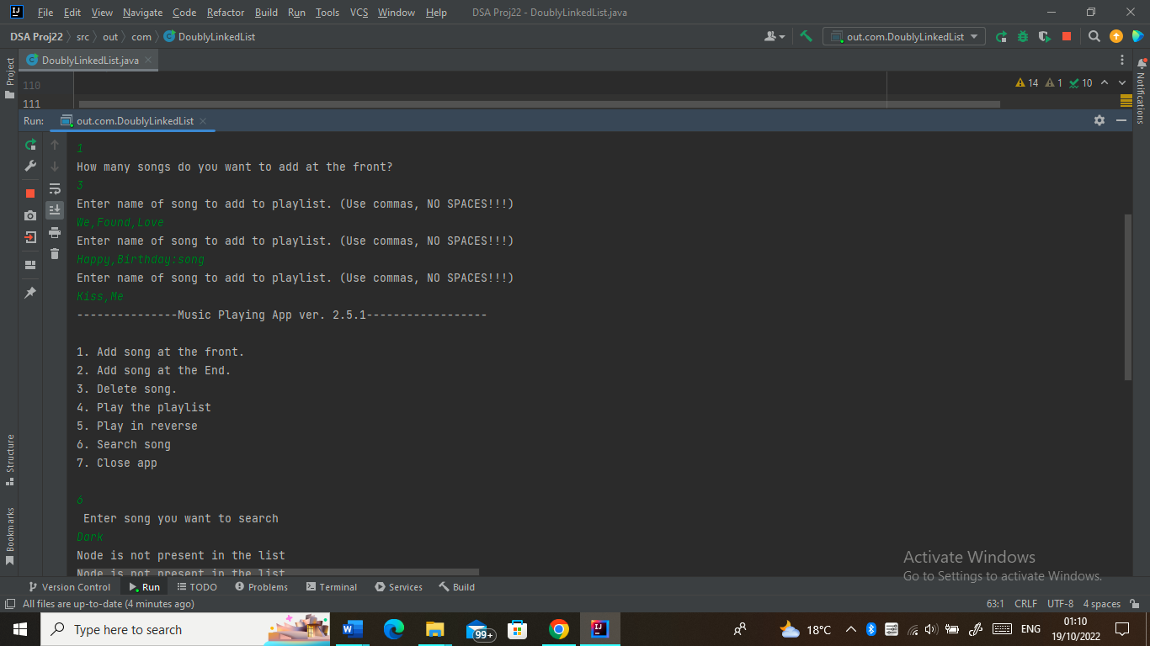

The song Kiss,Me is found at index 1

